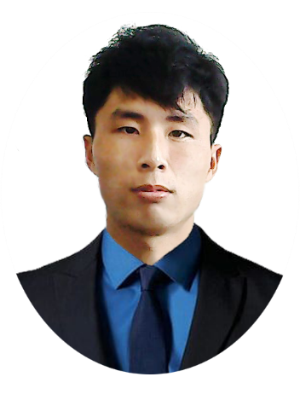Hideaki Miyamura

Greetings, Everybody! Customer satisfaction is my greatest pleasure!

Hideaki Miyamura, a Web & App Designer & Developer working for customers on their products in Tokyo, Japan

About Me

At home I like painting, reading books , food making

Out of the office you’ll find me dreaming of golf, playing bass guitar, and petting all the good dogs.

Contact Me

I occasionally take on freelance opportunities.

Have an exciting project where you need some help?

Send me a message, and let's chat.

+79831005200 live:.cid.bd0340c874262123

[dreamfullstacker@gmail.com](mailto:dreamfullstacker@gmail.com)

About Development

I’m passionate about building & designing delightful experiences with the combination of business, marketing and UX/UI design to make customers and users satisfied when they’re using products and services online.

I’ve spent the past 7+ years working across different areas of digital design; Front-end development, Email design, Marketing site pages, app UI/UX.

I also have experience in Blockchain, Ethereum(Solidity), Solana(Rust), NFT, and TradingView Chart with modern, trendy technology such as React, Vue, and App(Android and iOS).

I also have rich experience about Unity3D and 3Dmax modeling.

Strategy

*“Ask first. Before jumping into designing I always make sure that I'am asking the right questions and trying to accomplish the right challenges. This stage includes market research, competitive analyses, consulting and exploring possible solutions.”*

Design

*“Problem solving. At the end of this phase you’ll have a pixel perfect design for your app or website. During the transition from wireframes into the final design I create prototypes simulating final end results before development.”*

Development

*“Bringing designs to life. Since I’m a full stack developer, I can easily work in close collaboration with developers up until the finish line and beyond. In case of web projects I also do blockchain development.”*

Quality assurance

*“Transparent process. Complete overview of my design process through regular meetings. After the initial design versions I’m happy to do user testing with your customers to ensure the best possible solutions for their needs.”*

Blockchain & MER,VN Stack & NFT & App Senior Developer

**=========Blockchain=========**

*Chain : Bitcoin, Ethereum, Solana, BSC, Polygon, Avalanche, Tron, Eldron

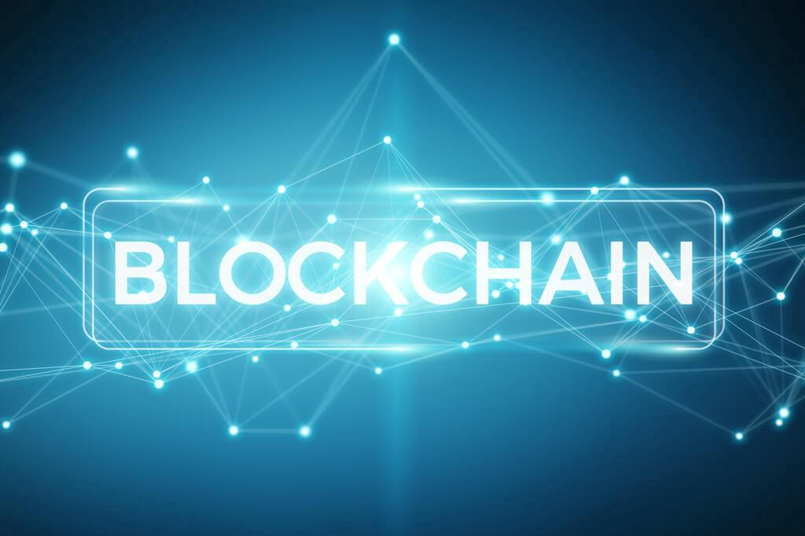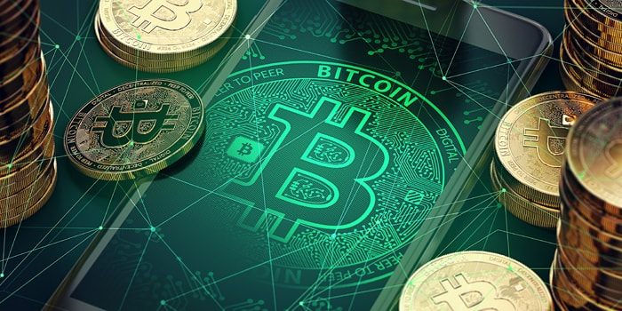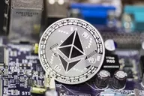

*Cryptocurrency : ERC-20, ERC-721, ERC-1155, BEP-2, BEP-20, BEP-721, TRC-20

*Wallet Connect : MetaMask, TrustWallet, Coinbase and more using Web3.js

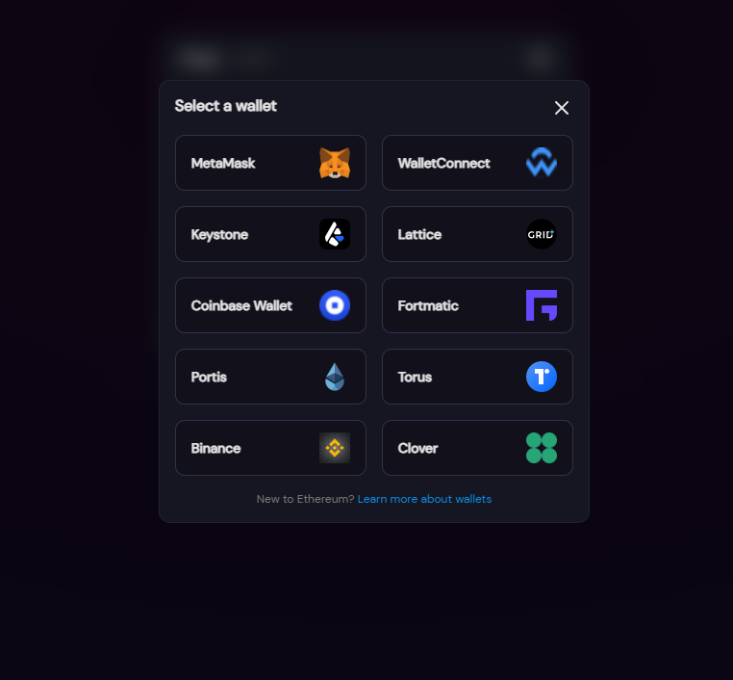

*NFT : NFT Minting, Staking, Marketplace

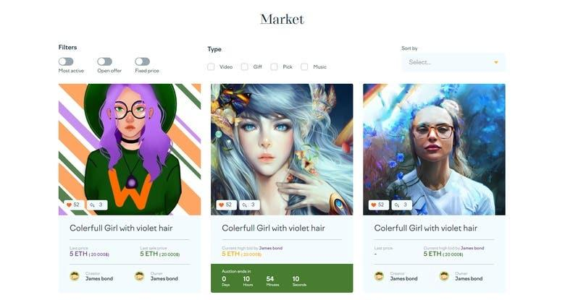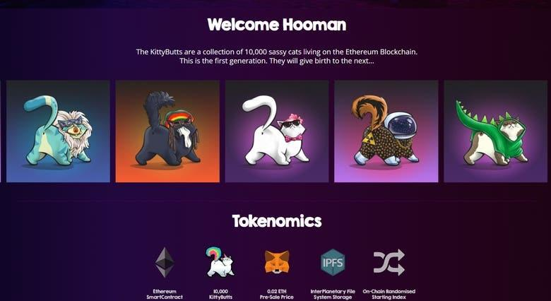

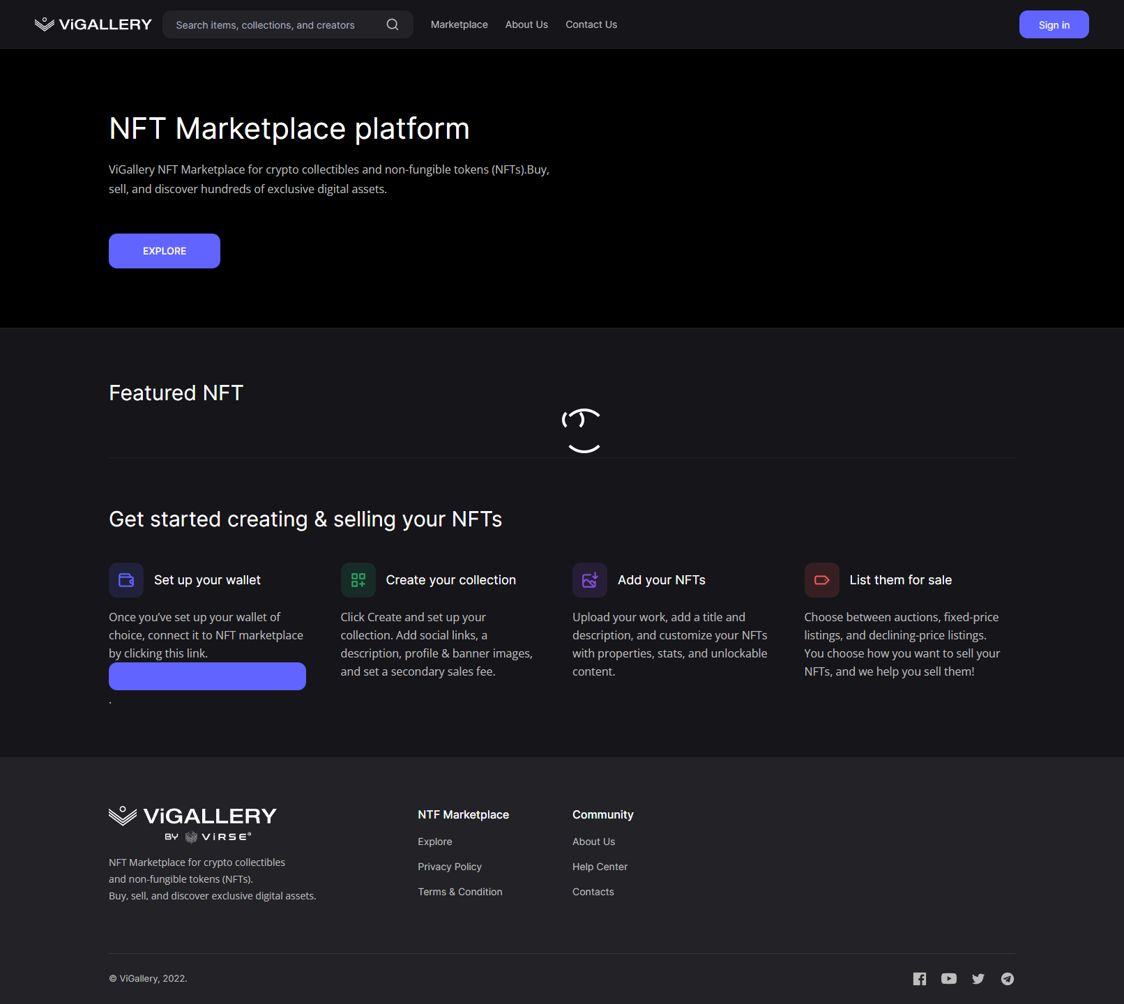 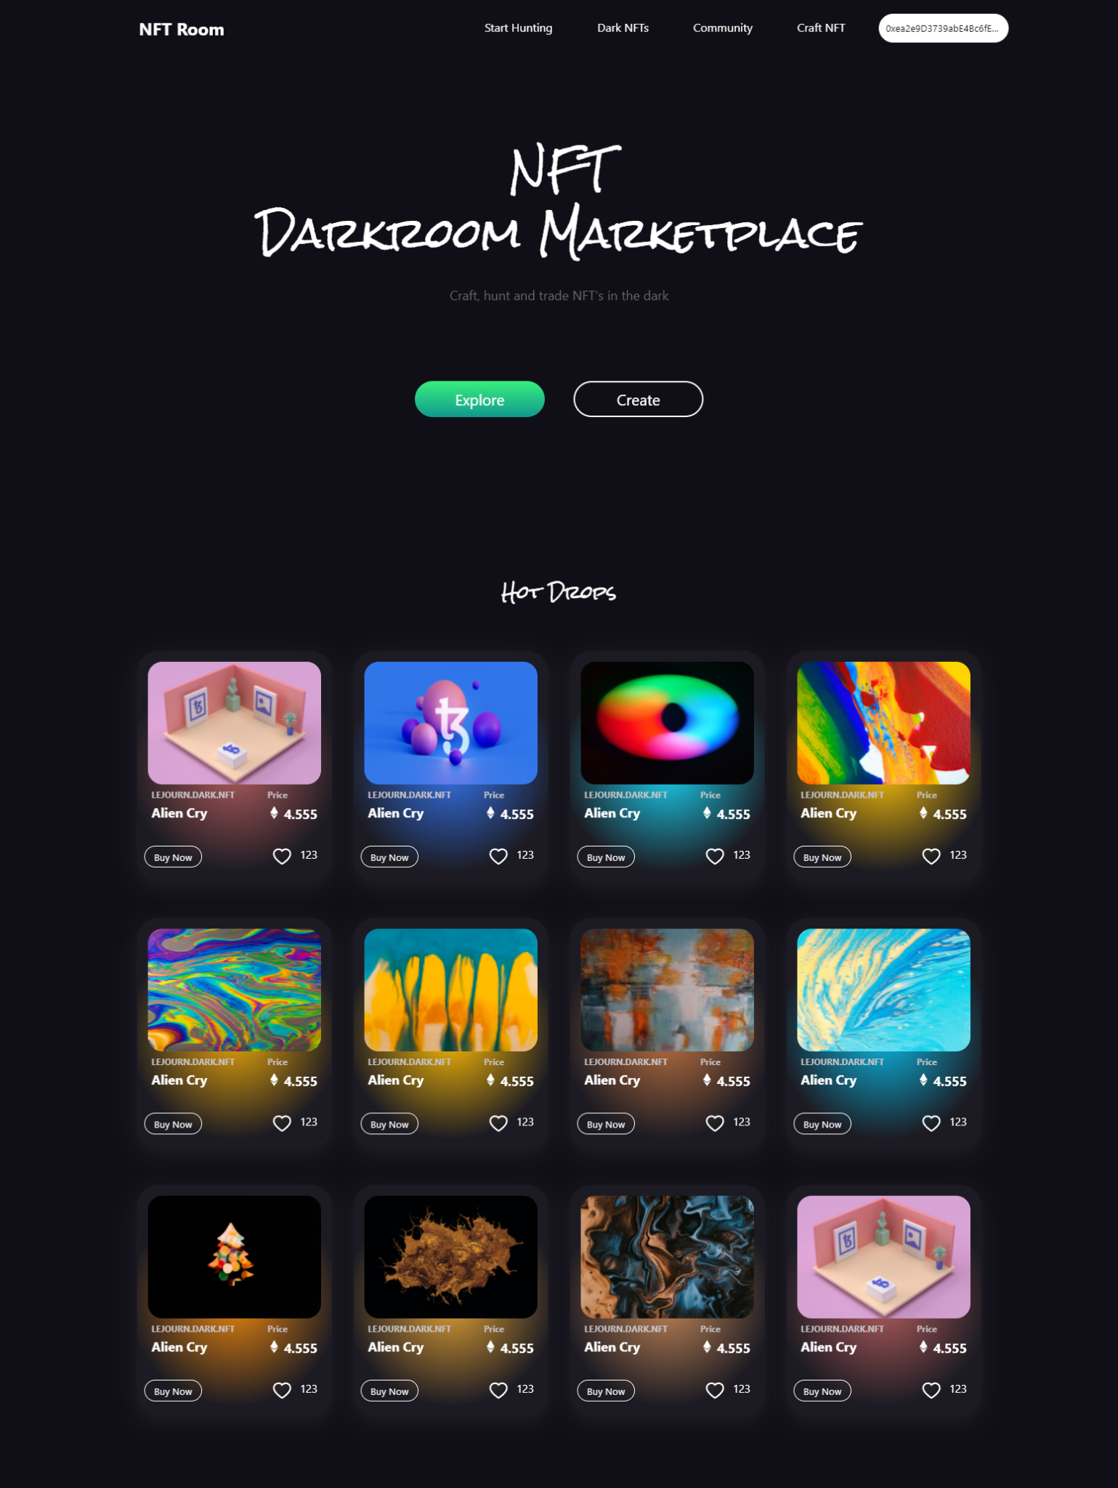

*Token : Swap, bridge, staking etc

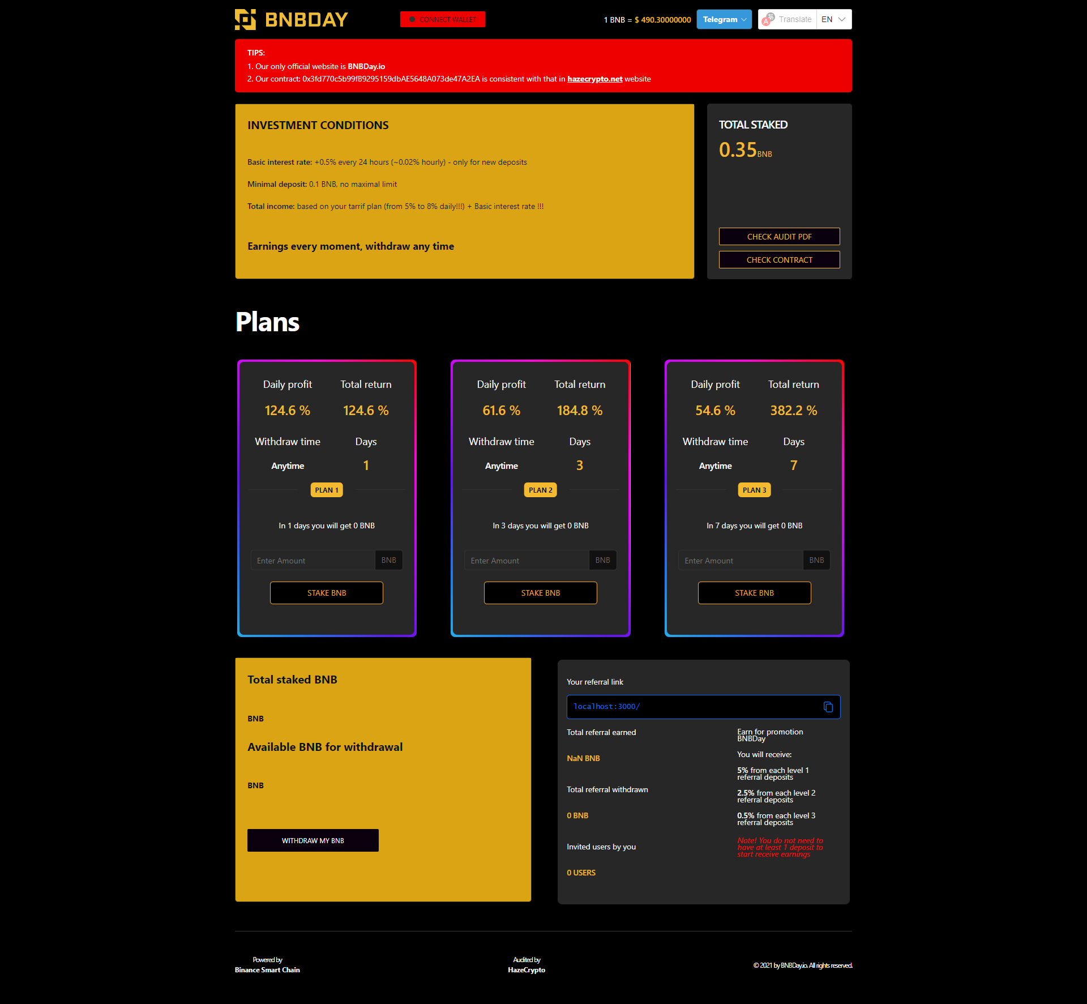

*Trading View

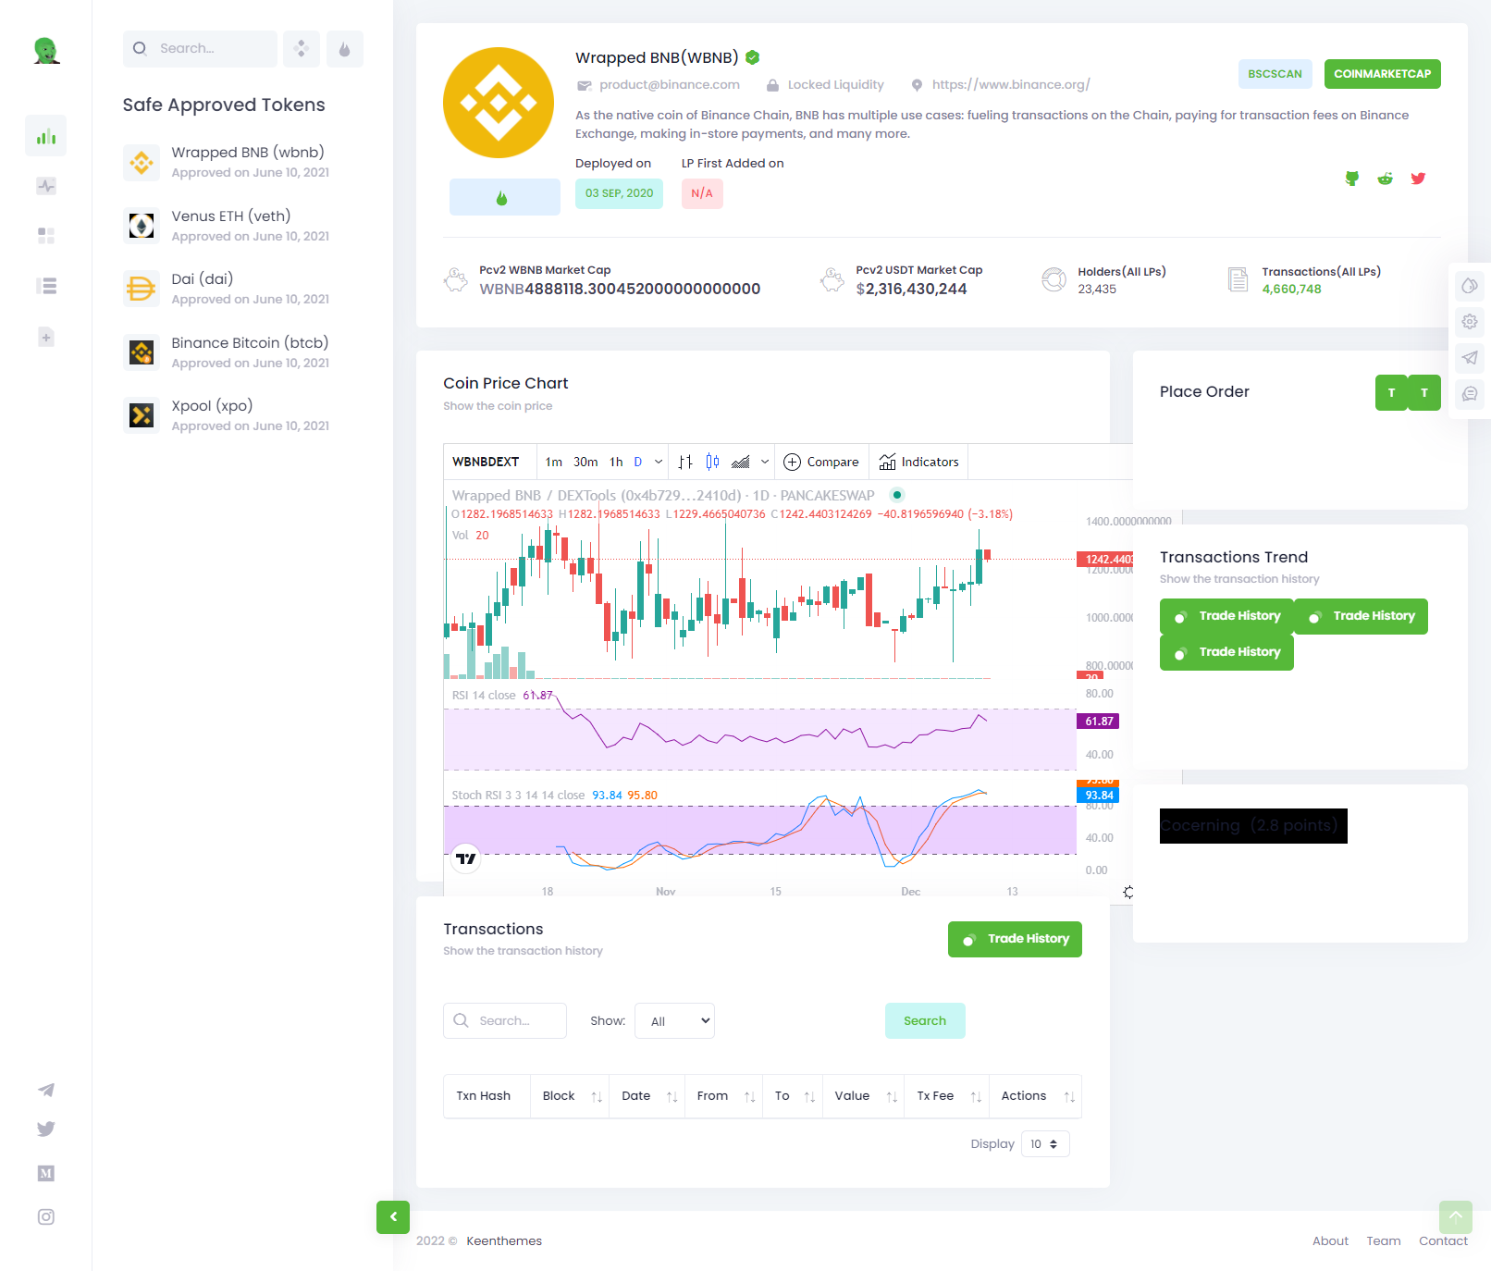

**=========Web Dev & Design==========**

**\*PHP framework : Codeigniter, Laravel, Wordpress**

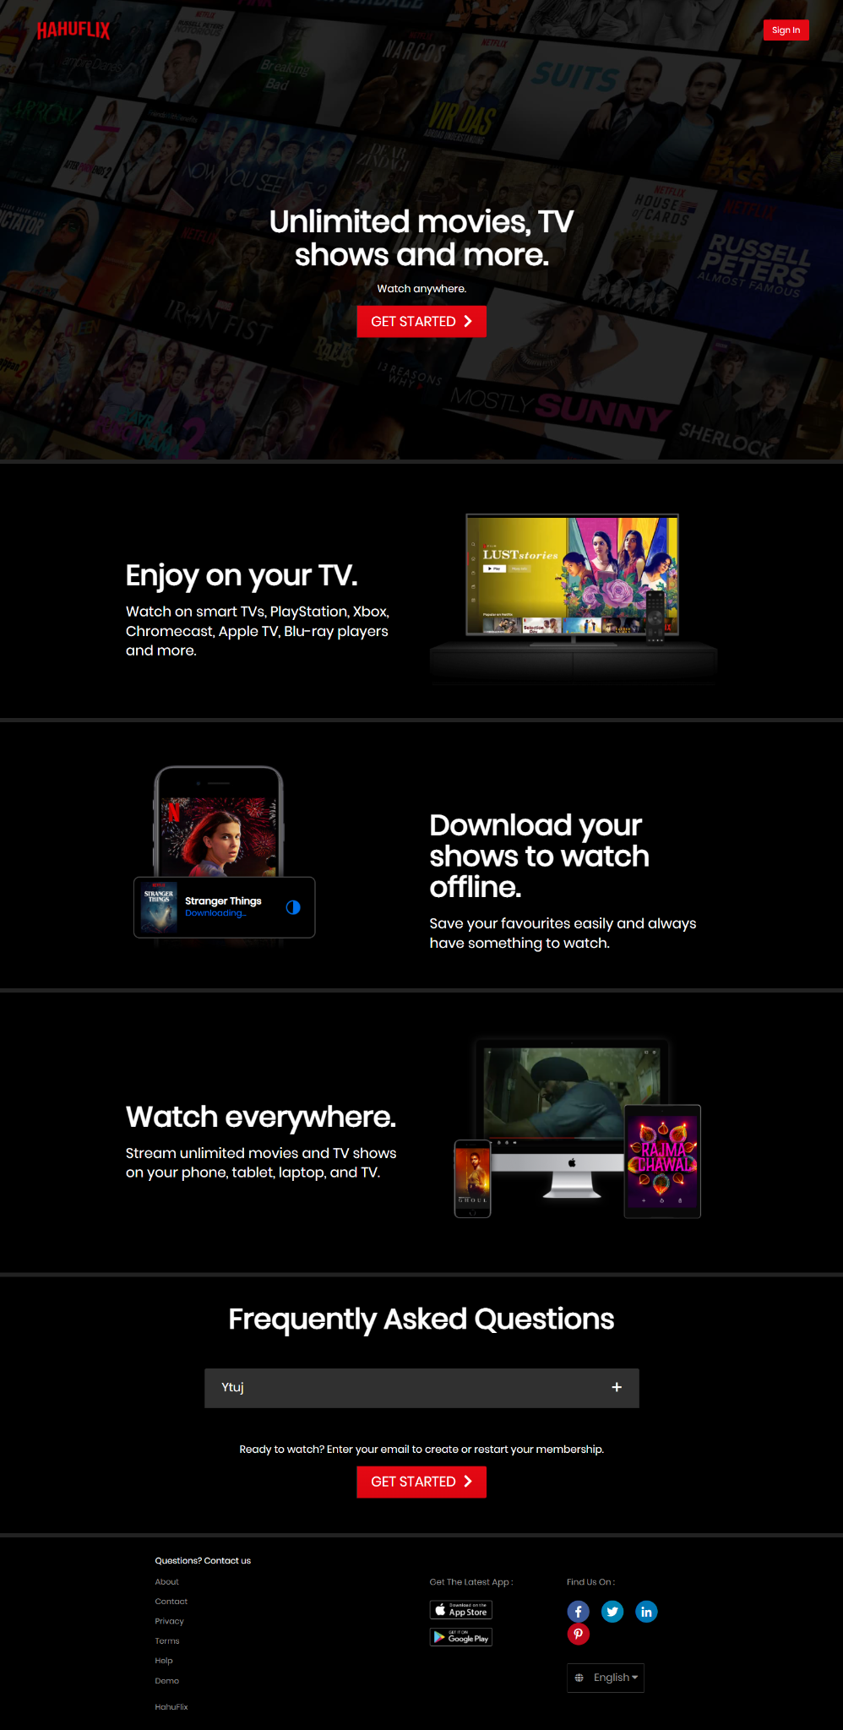Movie LiveStream

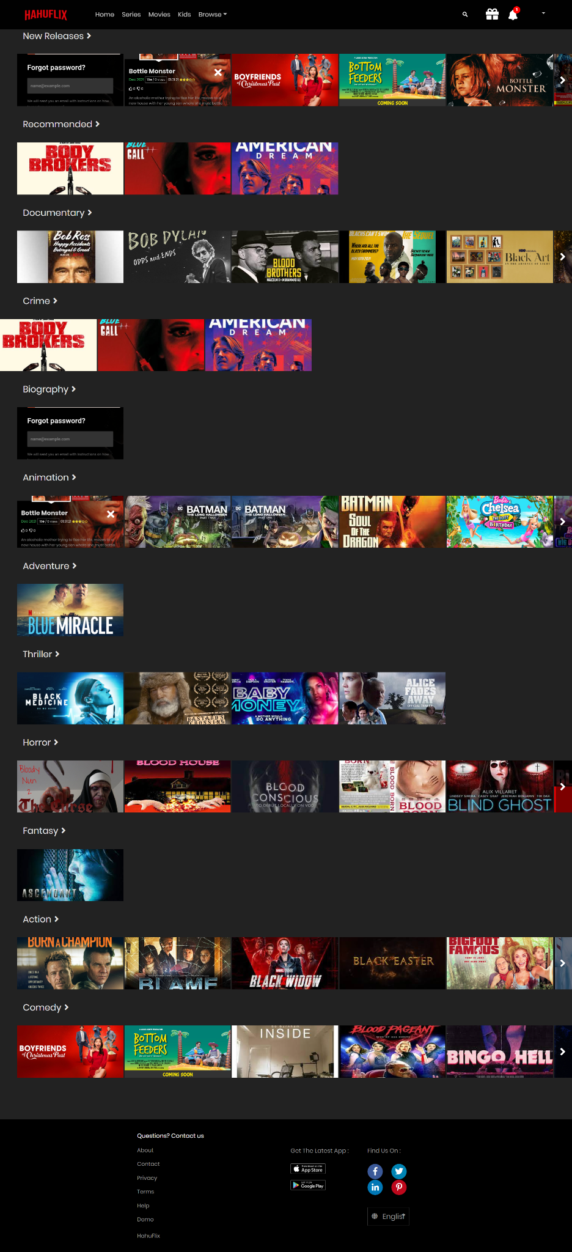

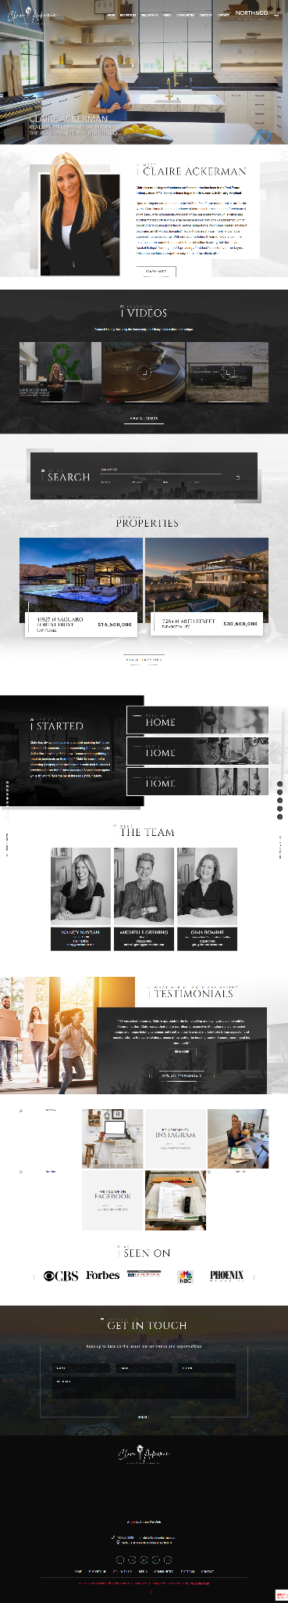

**Real EstateWebsite**

**\*Javascript : jQuery, React.js(NextJS, Gatsby), Vue.js(NuxtJS), AngularJS, Svelte**

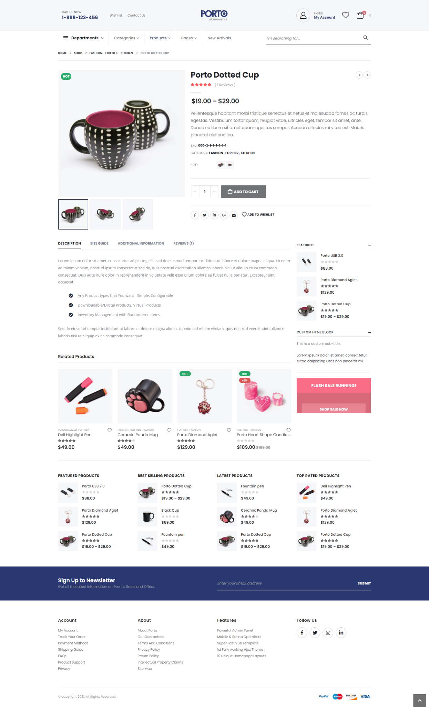

*Results for Innovative Companies*

*I will help businesses ideate, strategize, iterate, and launch their mobile and web apps while keeping cost, timelines, and objectives in mind.*

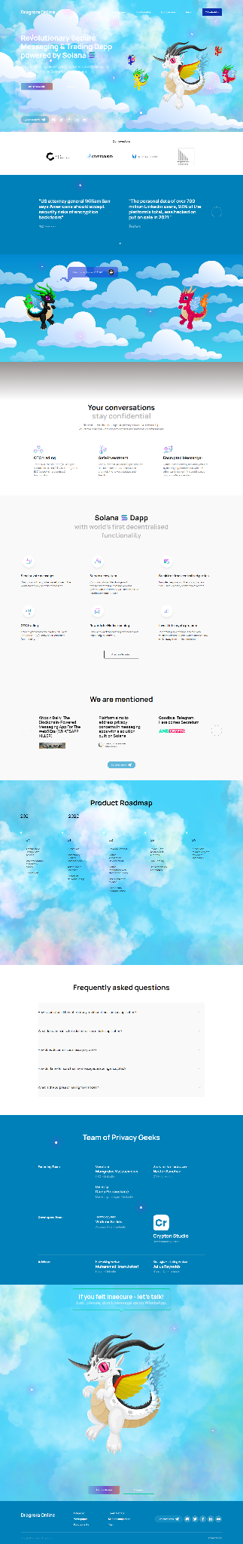

**\*Frontend Library : Bootstrap, TailwindCSS, MUI, ReactKit, AntD**

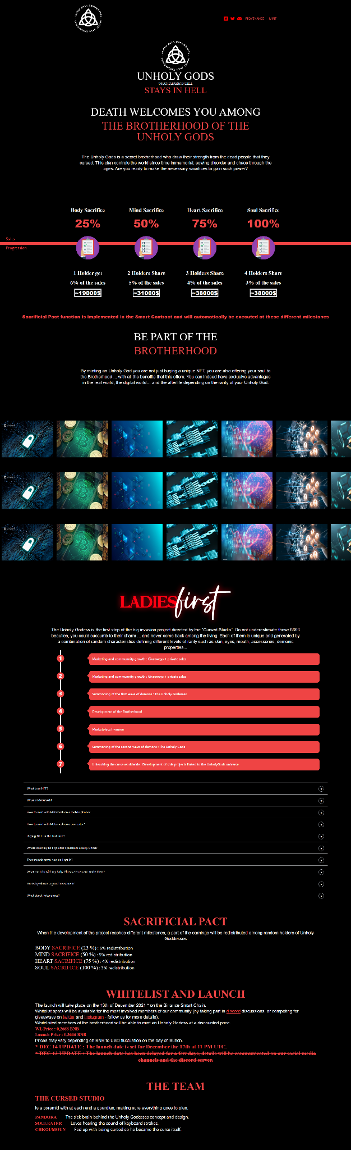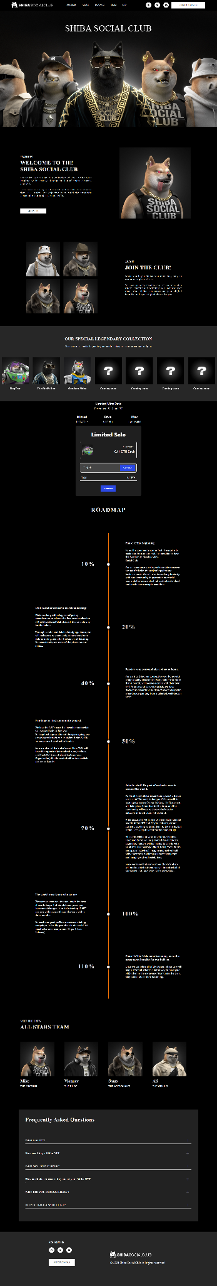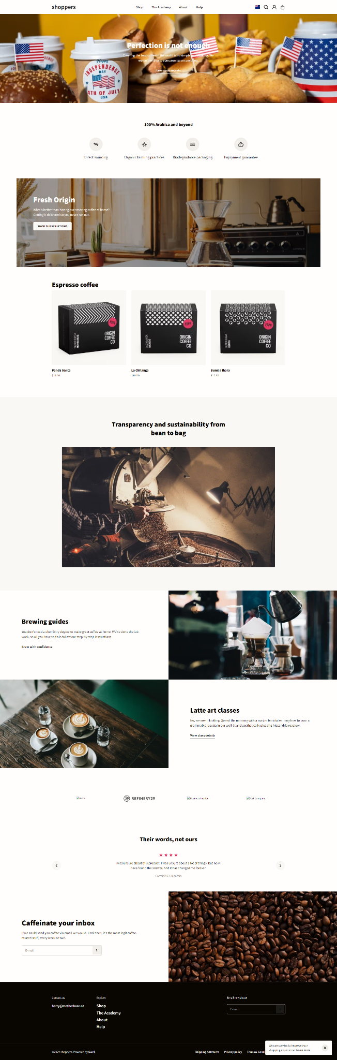

**\*Other : HTML5, Figma , Shopify**

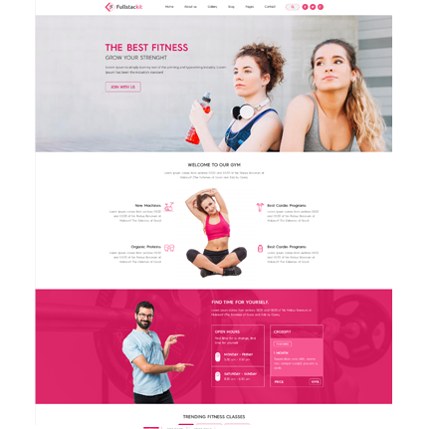Fitness

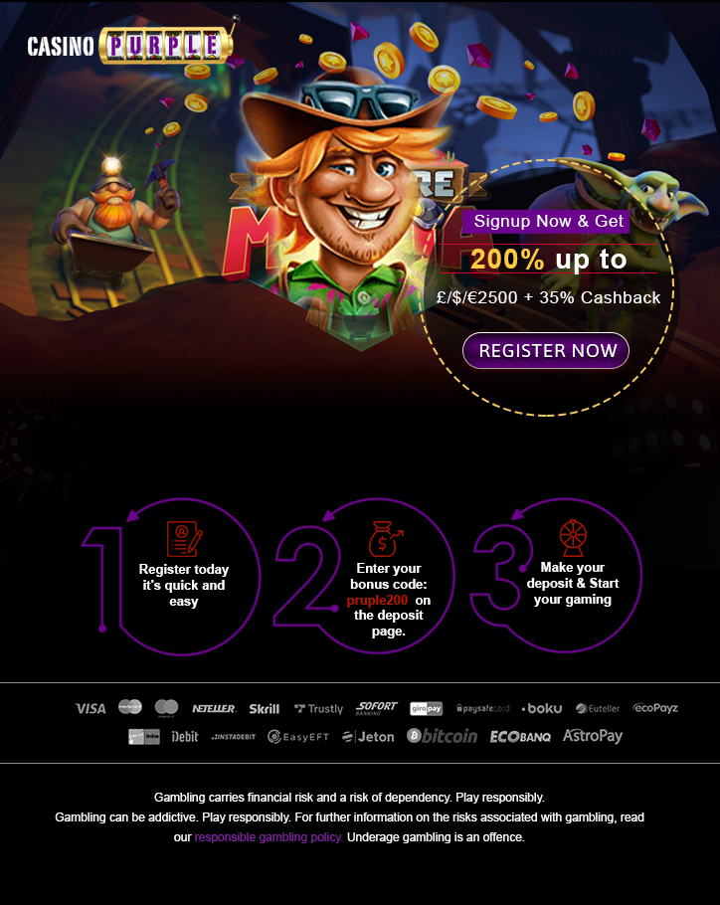Casino Game Design

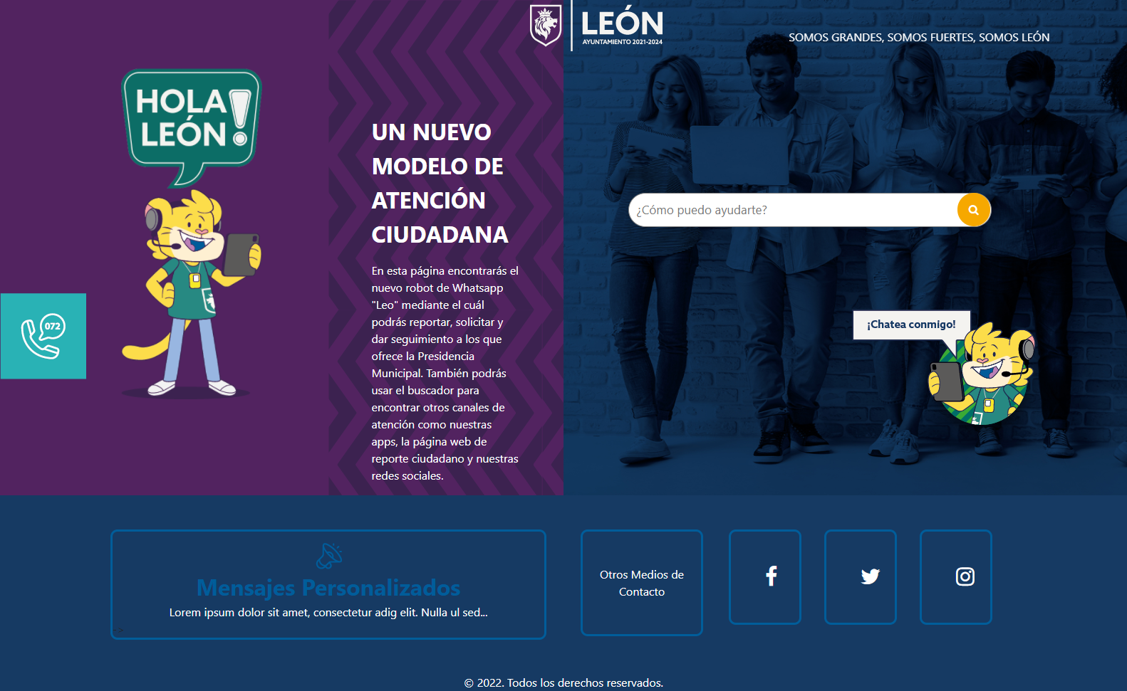

**=========Mobile Dev & Design=========**

*React Native

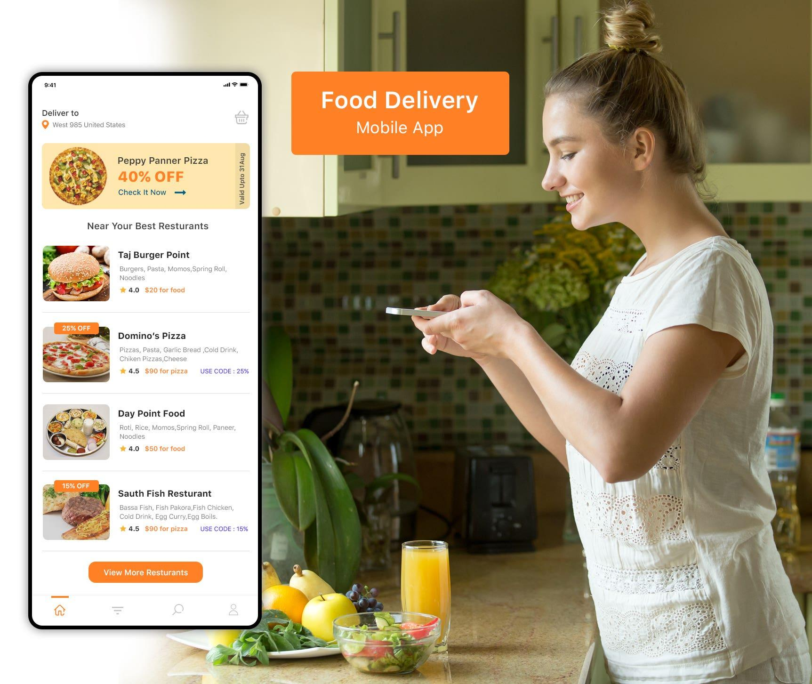

*Flutter

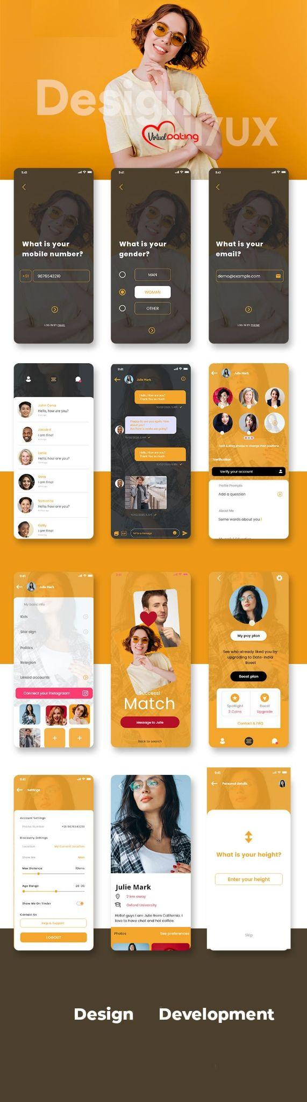Dating APP Design

**=========Windows Application=========**

*MFC: C++

*WPF: C#

**==========Unity3D & 3D modeling=========**

**\*Unity3D : Game, AR , VR**

**\*3D Modeling : 3dMax , Blender**

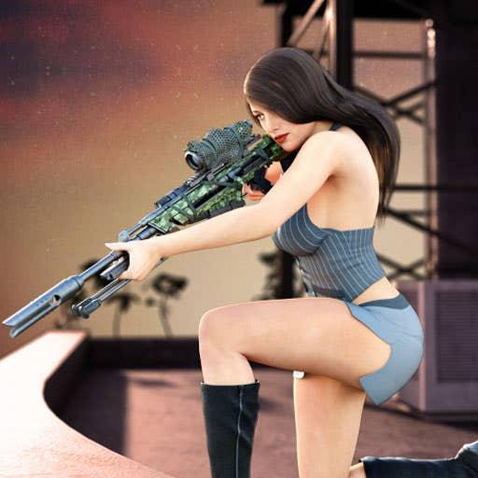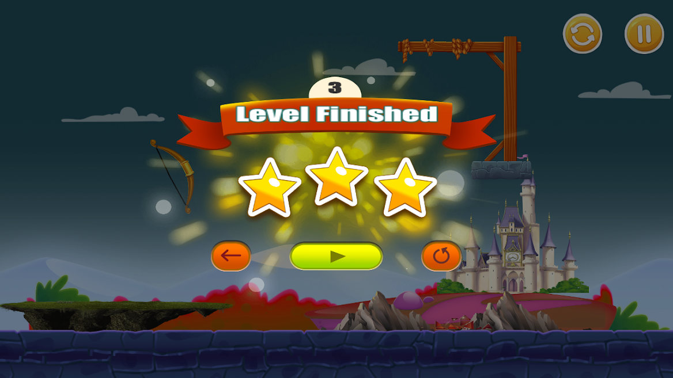

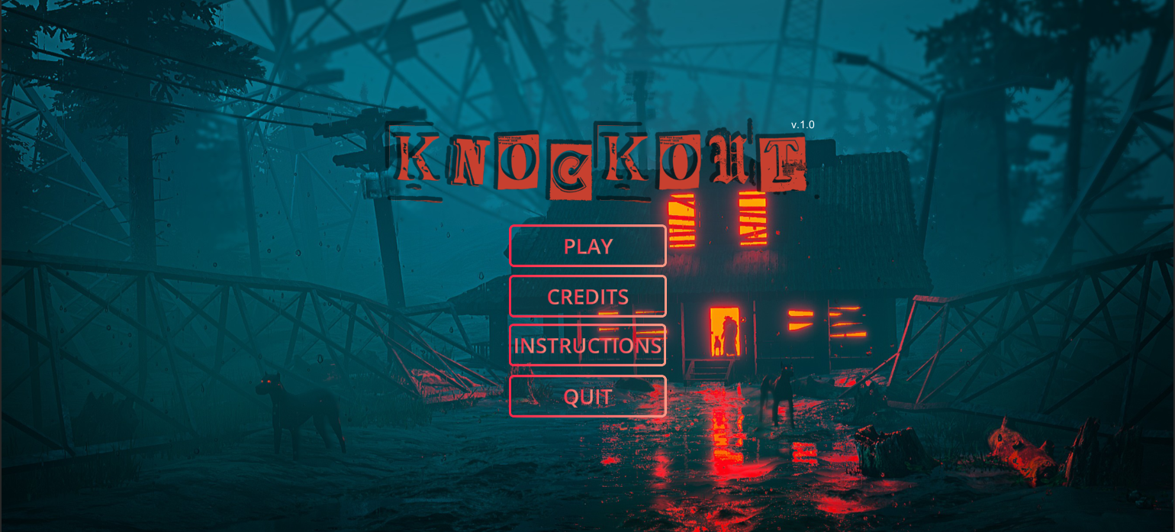

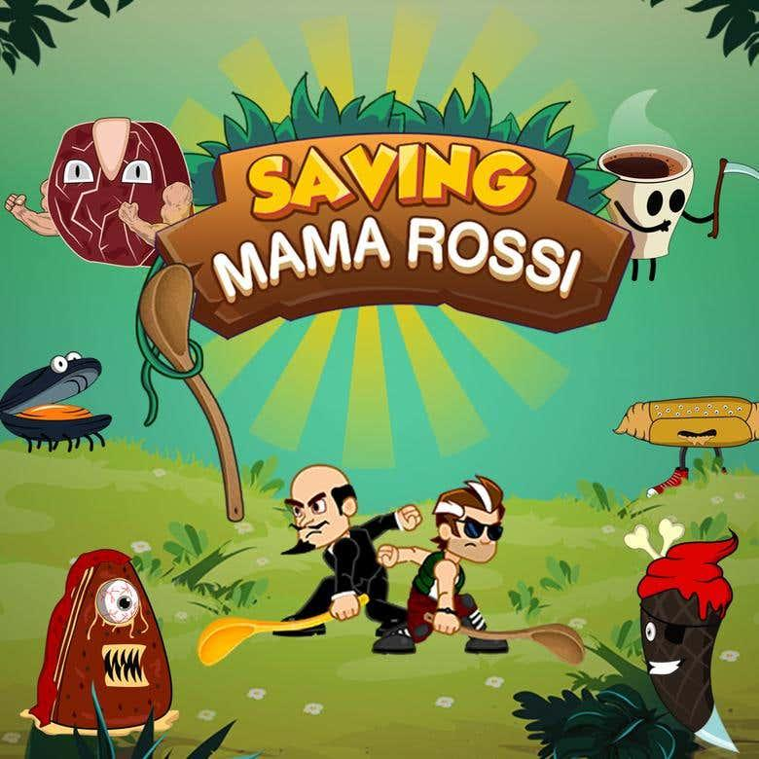

***Truth***

I guarantee that you will get more than you've expected.



Please don't hesitate to contact me for further discussion.



**If you want to test my skill, I am ready for this anytime.**

**Regular communication is really important to me, so let’s keep in touch!**



I will do my best for you

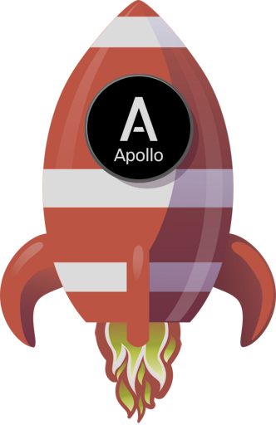

Best regards!❤